**Random Number:**

* A random number is a number chosen from a pool of limited or unlimited numbers that has no discernible pattern for prediction.
* The pool of numbers is almost always independent from each other.However, the pool of numbers may follow a specific distribution.

**Random Number Generation:**

* Random number generation is a process by which, often by means of arandom number generator (RNG), a sequence of numbers or symbols that cannot be reasonably predicted better than by random chance is generated.
* This means that the particular outcome sequence will contain some patterns detectable in hindsight but unpredictable to foresight.
* True random number generators can be hardware random-number generators (HRNGS) that generate random numbers, where in each generation is a function of the current value of a physical environment's attribute that is constantly changing in a manner that is practically impossible to model.
* This would be in contrast to so-called "random number generations" done by pseudorandom number generators (PRNGs) that generate numbers that only look random but are in fact pre-determined—these generations can be reproduced simply by knowing the state of the PRNG.

**Xorshift:**

The Xorshift variants, rand(), and basically all random number generator functions, are actually pseudorandom number generators. They are not "real random", because the sequence of numbers they generate depends on their internal state; but they are "pseudorandom", because if you do not know the generator internal state, the sequence of numbers they generate is random in the statistical sense.

**Case (1) :**

**Code:**

def xorshift():

  global xorshift_seed

  for i in range(n):

    xorshift_seed ^= xorshift_seed << 13   #Bitwise Left Shift

    xorshift_seed ^= xorshift_seed >> 17   #Bitwise Right Shift

    xorshift_seed ^= xorshift_seed << 5

    xorshift_seed %= 2**32   #The modulus limits it to a 32-bit number

    return xorshift_seed

n=int(input("Enter No. of Random You want to obtain : "))

upperLimit=int(input("Enter The Upper Limit Of Random No. : "))

xorshift_seed += 100

print("Random No. Are : ")

for i in range(n):

  print(xorshift()%upperLimit)

**Output:**

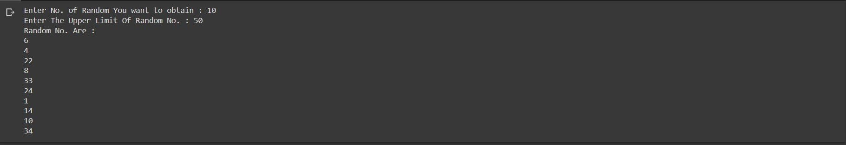

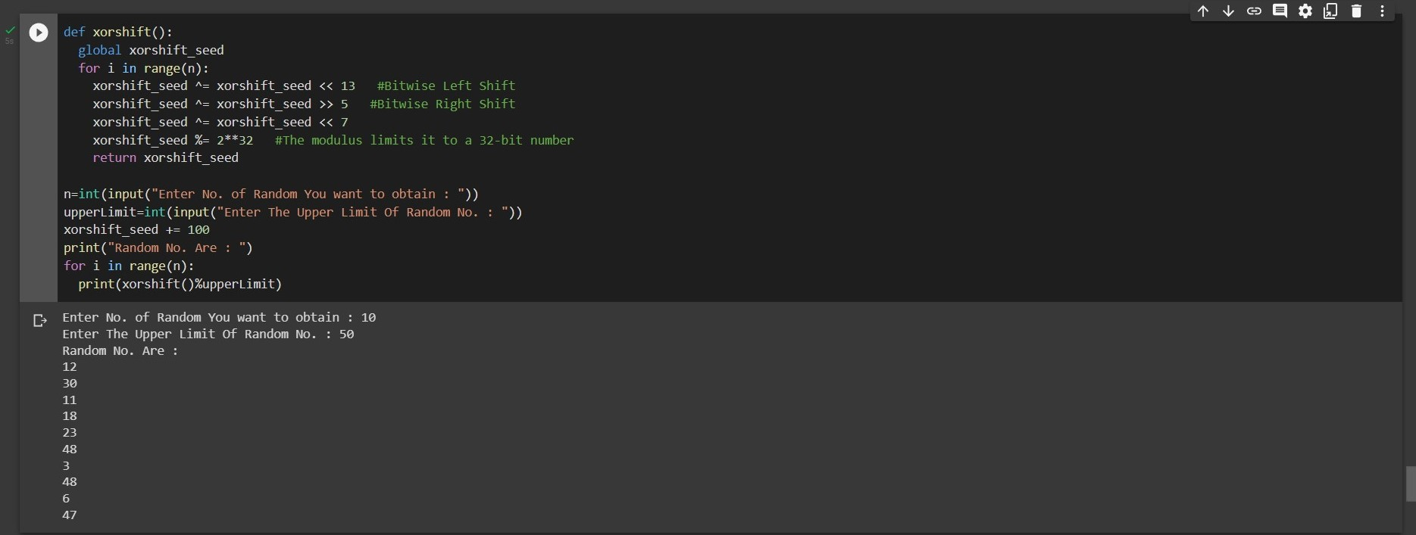

**Case (2) :**

**Code:**

def xorshift():

  global xorshift_seed

  for i in range(n,-n,-1):

    xorshift_seed ^= xorshift_seed << 13   #Bitwise Left Shift

    xorshift_seed ^= xorshift_seed >> 5   #Bitwise Right Shift

    xorshift_seed ^= xorshift_seed << 7

    xorshift_seed %= 2**32   #The modulus limits it to a 32-bit number

    return (xorshift_seed)

n=int(input("Enter No. of Random You want to obtain : "))

upperLimit=int(input("Enter The Upper Limit Of Random No. : "))

xorshift_seed += 100

print("Random No. Are : ")

for i in range(n):

  print(((-1)**xorshift())*(xorshift()%(upperLimit+0.3)))

**Output:**

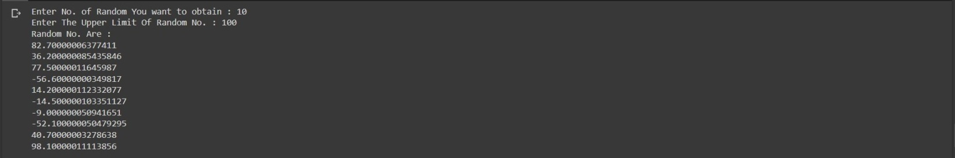

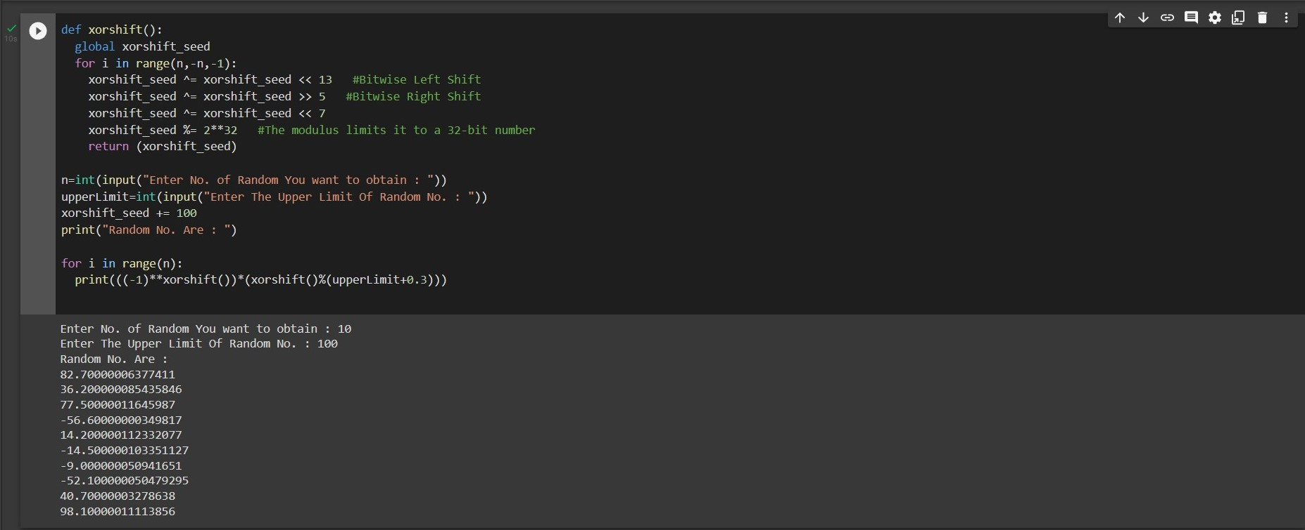

**-X-X-X-**